Andy Naro, Colin Murphy, Joseph Cefalo

1.

select fname

from privateowner

where ownerNo in (select ownerNo

from propertyforrent

where city = 'glasgow');

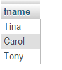

2.

select round(AVG(salary)) as avg,

round(MAX(salary)) as max,

b.city

from staff s, branch b

where s.branchNo = b.branchNo

group by b.city

order by b.city;

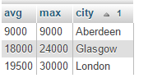

3.

SELECT AVG(rent) as AvgRent, staffNo, city

FROM PropertyForRent

WHERE staffNo IN (SELECT staffNo FROM Staff WHERE sex = 'F')

GROUP BY city

ORDER BY city;

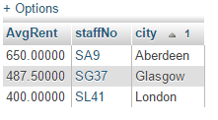

4.

SELECT address, telno

FROM PrivateOwner p

JOIN(

SELECT ownerNo

FROM PropertyForRent

GROUP BY ownerNo

HAVING COUNT(\*)>1

) r

ON p.ownerNo=r.ownerNo;

